Acquire certificate at Comodo/Sectigo through Namecheap

1) generate a keystore:
- keytool -genkey -keysize 2048 -keyalg RSA -alias tomcat -keystore keystore.jks
- password (default) changeit
- first and last name: alvanklaveren.com
- organizational unit: President
- name of organization: AVK
- city: Sappemeer
- province: Groningen
- country code : NL
- press enter to use same keystore password (changeit)

2) Make it a pkcs12 keystore
- keytool -importkeystore -srckeystore keystore.jks -destkeystore keystore.jks
-deststoretype pkcs12

- now make a bakcup of the keystore: cp keystore.jks keystore.jks.backup

3) Generate the csr:
- keytool -certreq -alias tomcat -file tomcat.csr -keystore keystore.jks

4) Go to namecheap and get (a new) certificate (reissue)

Click on the dropdown arrow and select “reissue”
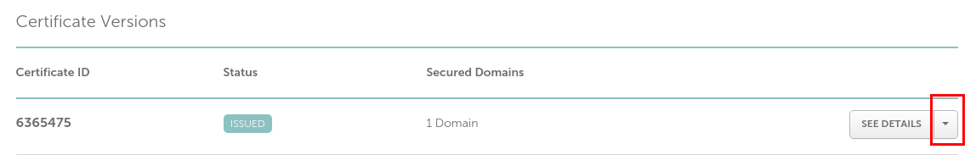

Now copy the content of the CSR generated in step 3 into the “Enter CSR” box and press “Next”
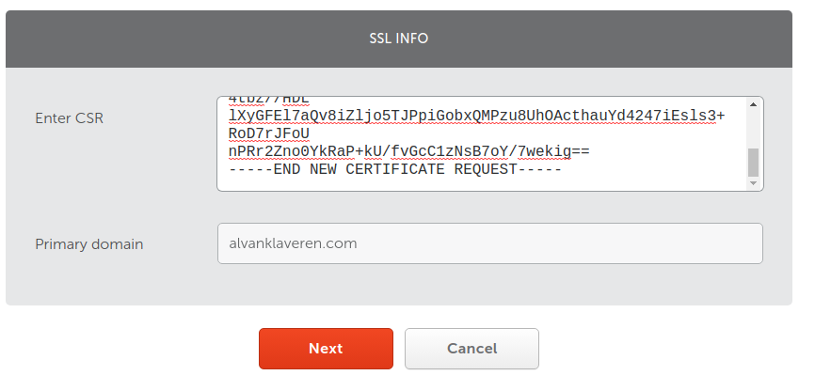

In the next screen, choose “Any other server”, because we are using apache2 on Digital Ocean.
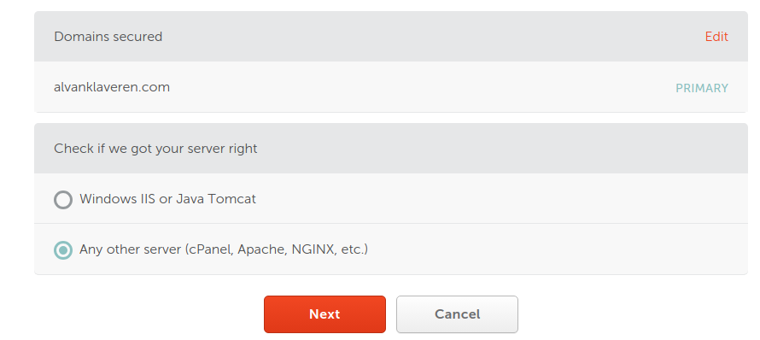

Next, choose Email as DCV method (by far the easiest), and follow the instructions in the emails to get the certificate and root/intermediate bundle.

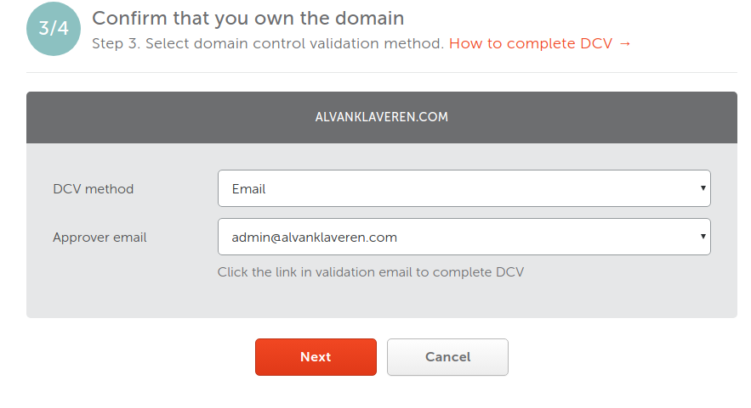

The first (comodo/sectigo) email asks you to enter the validation code at the given link in the email.
When you entered the code, a second email arrives containing a zip file. This zipfile contains a bundle and your domain certificate.
In my case, these are alvanklaveren_com.crt and alvanklaveren_com.ca-bundle.

The bundle contains both the root and intermediate certificate, so we split this into one root.crt, and one intermediate.crt.
Important: The bundle starts with the intermediate, and ends with the root certificate.

Next we copy these to the keystore location, together with alvanklaveren_com.crt. We are now going to import them into the keystore.

REMEMBER: we made a copy of the keystore in case something goes wrong.

5) import certificates:
first we import the root, then the intermediate, then the domain:
- keytool -import -trustcacerts -alias root -file root.crt -keystore keystore.jks
- keytool -import -trustcacerts -alias intermediate -file intermediate.crt -keystore keystore.jks
- keytool -import -trustcacerts -alias tomcat -file alvanklaveren_com.crt -keystore keystore.jks

The intermediate file is important, because otherwise (older) Android devices may give a “website
unsecure” error.

6) Now to get things up and running on the Digital Ocean droplet, modify the following
configuration files:
- /opt/tomcat/conf/server.xml:
Make sure this is in place to serve https

<!-- A "Connector" represents an endpoint by which requests are received
and responses are returned. Documentation at :
Java HTTP Connector: /docs/config/http.html
Java AJP Connector: /docs/config/ajp.html
APR (HTTP/AJP) Connector: /docs/apr.html
Define a non-SSL/TLS HTTP/1.1 Connector on port 8080
-->
<Connector port="8080" protocol="HTTP/1.1" connectionTimeout="60000" redirectPort="8443"/>

<Connector port="80" protocol="HTTP/1.1" connectionTimeout="60000" redirectPort="8443"/>

<Connector port="443" protocol="HTTP/1.1" SSLEnabled="true" maxHttpHeaderSize="8192"
maxThreads="150" minSpareThreads="25" maxSpareThreads="75" enableLookups="false"
disableUploadTimeout="true" acceptCount="100" connectionTimeout="60000" scheme="https"
secure="true" clientAuth="false" sslProtocol="TLS" keystoreFile="conf/keystore.jks"
keystorePass="changeit"/>

<Connector port="8443" protocol="HTTP/1.1" SSLEnabled="true" maxHttpHeaderSize="8192"
maxThreads="150" minSpareThreads="25" maxSpareThreads="75" enableLookups="false"
disableUploadTimeout="true" acceptCount="100" connectionTimeout="60000" scheme="https"
secure="true" clientAuth="false" sslProtocol="TLS" keystoreFile="conf/keystore.jks"
keystorePass="changeit"/>

Now as you can see, both 8080 and 80 redirect to 8443, because getting port 443 working on
digital ocean is a nightmare.

Next, we need to tell the application which folders to serve. We want all to be encrypted, accept
for the gameshopmobile (encryption makes things slower, so we exclude this page from
httpsrequired). Find the web.xml in your sources and add the following to it:
<web-app …. >
…

<security-constraint>
<web-resource-collection>
<web-resource-name>server</web-resource-name>
<url-pattern>/*</url-pattern>
</web-resource-collection>
<user-data-constraint>
<transport-guarantee>CONFIDENTIAL</transport-guarantee>
</user-data-constraint>
</security-constraint>

<security-constraint>
<web-resource-collection>
<web-resource-name>server</web-resource-name>
<!-- exclude the call to gameshopmobile. this page is NOT https protected !! -->
<url-pattern>/gameshopmobile/*</url-pattern>
</web-resource-collection>
<user-data-constraint>
<transport-guarantee>NONE</transport-guarantee>
</user-data-constraint>
</security-constraint>

</web-app>

This should get some things working….

